Morton Village Hall
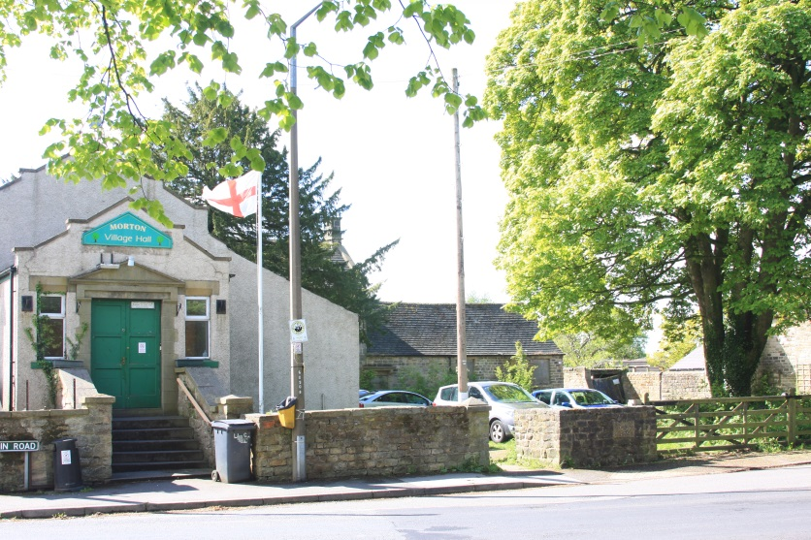
Considered Report to the Parish Council.
- Introduction
This report is a review regarding the Village Hall in Morton and has been compiled to provide a considered view of the situation which will enable the Parish Councillors to decide the next stage of the project.
- History
The Village Hall was constructed in 1680 as the village malt house and in 1735 the building
And the adjoining house (Morton House) was sold to the Oldham Family.
In 1834 the malt house was closed due to the advent of breweries emerging in the area and the opening of several public houses.
In 1923 the hall was purchased by General and Mrs GM Jackson and then sold to the Morton Miners Welfare with Morton House being adapted for the Miners Welfare Club
In 1975 the hall was purchased by Morton Parish Council and converted into the Village Hall. The hall is manged by the Village Hall Management Committee on behalf of the Community on a 25 years lease. This is a registered Charity and operates on a none profit basis

- The story so far
Since 2002 the need to improve the village hall was recognised but until 2015 little progress had been made and the general state of the building has been in decline to the point it is no longer fit for purpose. Several options have been considered for the building including rebuild and reciting.
A village survey completed in 2016 resulted in a clear desire to keep the current building and make the recommended improvements which included a new kitchen and disabled access.
A strip of land was gifted to the Parish Council in 2016 from the owner of The Morton Manor which will enable the hall to be widened and an access ramp installed.
Planning approval for the proposed changes was obtained in November 2017 and building regulations approval given in May 2018.
The next stage is to obtain the funding to enable the project to go ahead.
The annual precept was increased for 2018/2019 at the Parish Council meeting in February 2018 and the budget agreed for the following year.

- Options for consideration

Outcomes for the project
- Improved access to a range of existing and new community services, activities and events by local residents, leading to clear improvements in wellbeing
- Residents will report an increased sense of community through having greater involvement in meetings, activities and local projects
- Older and more vulnerable residents feel less isolated through engagement in new community activities.

An options appraisal report was completed in 2015 when a number of options for the hall were considered these included:
Option 1: Do Nothing
Option 2: Refurbishment of the existing facilities
Option 3: Refurbishment and enhancement of existing facilities
Option 4: New Build New Site
Option 5: New Build existing Site

For each option a number of criteria were
used and assessed using the following scale, with option 1, the current situation, forming the frame of reference:

3 = More than Sufficient
2 = Sufficient
1 = Partially Sufficient
0 = Not met at all

 | Options |  | 1 | 2 |  | 3 |  | 4 | 5
 | Category |  | Do Nothing | Refurbish of the existing facilities |  | Refurbish and enhancement of existing facilities |  | New Build New Site | New Build old Site
 | Community Services |  | 0 | 1 |  | 3 |  | 3 | 3
 | Opportunities to Attract Business |  | 0 | 1 |  | 2 |  | 3 | 2
 | Capital Cost |  | 2 | 2 |  | 1 |  | 0 | 0
 | Revenue Cost |  | 1 | 1 |  | 2 |  | 3 | 2
 | Ease of Management |  | 2 | 2 |  | 2 |  | 2 | 2
 | Future needs |  | 0 | 1 |  | 3 |  | 3 | 2
 | Risk |  | 0 | 3 |  | 2 |  | 1 | 2
 | Environmental Impact |  | 0 | 0 |  | 3 |  | 3 | 3
 | Deliverability |  | 3 | 3 |  | 2 |  | 1 | 1
 | Timescale |  | 3 | 2 |  | 2 |  | 1 | 1
 | Synergies: |  | 0 | 0 |  | 2 |  | 3 | 2
 | Totals |  | 11 | 16 |  | 24 |  | 23 | 20
 | Ranking |  | 5 | 4 |  | 1 |  | 2 | 3

Based on the options review it was decided to follow option 3
Refurbish and enhancement of existing facilities

- Community Involvement
The Community has been involved with the project from an early stage.
Open meetings were held in 2016/2017 and a village survey was completed by over 300 residents giving a clear indication of how the community wanted the project to progress.
During the consultation it was also accepted by a high majority that an increase in the precept if required would be acceptable to help support the project.
- Planning approval
Plans have been completed and planning approval was obtained in November 2017 this was followed by building regulation approval in May 2018.
- Tender Options
Tender documents have been produced and quotations requested from six contractors. Quotations have been received from three building contractors
a) G K Developments £193,602
b) Andrews the builder £201,270
c) PJCole builders £182,947
*the above quotes do not include VAT at 20%
- Financial
The Village Hall Management Committee is a not for profit charity and have no funds available to finance the project. The Parish Council have allocated £25,000 to help develop the project and have accrued another £35,000 in reserves giving a total of £60,000, but this is insufficient to finance the whole project. In order to finance the project further funding will be required. In recognition of this the annual precept was increased after full council approval for 2018/2019.
- Grant funding
Grant applications have been made to several organisations including the Big Lottery. Although we reached the final stages with the Big Lottery the end result was unsuccessful.
The latest application to Viridor credits for £91,000 has also reached the final stages and we are waiting for the result

- Proposals for review
Based upon the details included within this report and consultation across the Community the following proposal is presented for consideration by the Parish Councillors.
- The Village Hall is fully refurbished as per the lowest quote received.
- £60,000 funding is provided from the Parish Council reserves.
- An additional £5,000 is provided from the Village Hall Management Committee
- Grant provided by Viridor Credit if successful.
- Balance of funds provided by the Parish Council, obtained from a loan from the Public Works Loan Board and financed via the village precept.
Project cost based on the lowest quotation £182,947 + vat £36,598* = £219,536
Funds from existing Parish Council reserves £60,000
Fundraising contribution from Village Hall £5,000
Shortfall £ 154,536
Viridor Credits tbc
Parish Council PWLB £150,000
*VAT may be a recoverable cost
This report is provided to the Parish Council for consideration at the meeting on 25th June 2018.
John Funnell
Chair
Morton Parish Council

*Footnote
The village Hall is owned by the Parish Council and leased to the Village Hall Management Committee.
The above report was considered at the meeting on the 25th June and it was proposed a subcommittee meet to review the preferred way forward. This meeting took place on the 9th July and was attended by most councillors.
At this meeting it was discussed how best to take the project forward with or without the grant from Viridor credit which at this meeting was not approved.
The meeting agreed to recommend applying for a loan of £150,000 from the PWLB which would enable the basic project to go ahead without a grant from Viridor. If the grant was successful then the project could go ahead and the additional funds would mean that additional items could be included in the project which had been phased for completion at a later stage.
The project was always planned to be a partnership between the Village Hall Management Committee who are a registered charity and the Parish Council.
A resolution to apply for a Loan from the Secretary of State via a Public Works Loan Board was passed unanimously at the Parish Council meeting on the 16th July.

This report was accepted by the Parish Council at the meeting on the 25th June with a resolution passed to apply for the loan from the Secretary of State via the Public Works Loan Board at the Parish Council meeting on the 16th July 2018.
If anyone wants to comment on this report and the resolution with any suggestions, recommendations or opinion please contact the Parish Clerk. clerk@mortonparishcouncil.org.uk

